**Performance Comparison of PL/SQL Interpreted vs. Native Code**

INTERPRETED

CREATE OR REPLACE PROCEDURE longproc IS

v_number PLS_INTEGER;

BEGIN

FOR i IN 1..50000000 LOOP

v_number := v_number * 2;

v_number := v_number / 2;

END LOOP;

END longproc;

/

BEGIN

longproc;

END;

/

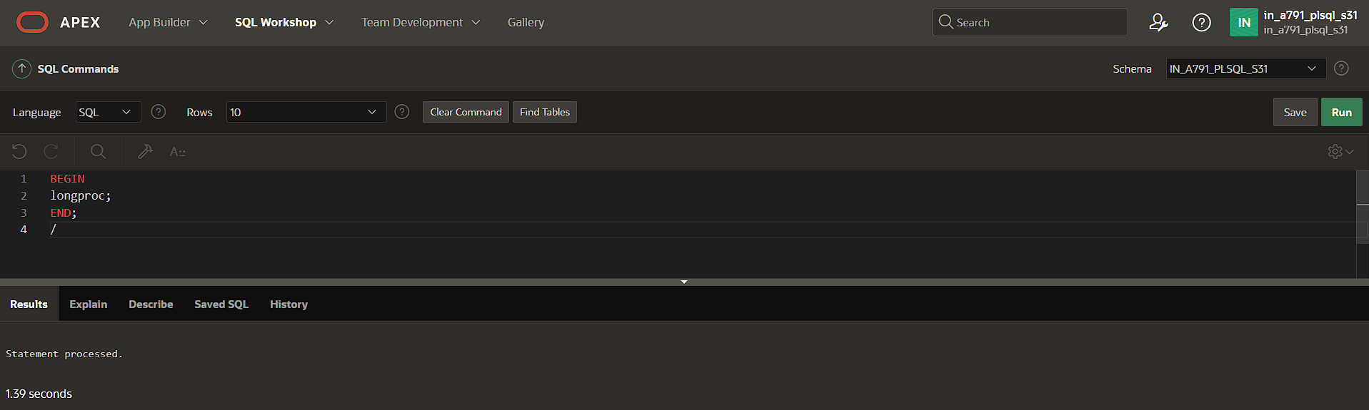

NATIVE CODE

ALTER SESSION SET PLSQL_CODE_TYPE = NATIVE;

CREATE OR REPLACE PROCEDURE longproc IS

v_number PLS_INTEGER;

BEGIN

FOR i IN 1..50000000 LOOP

v_number := v_number * 2;

v_number := v_number / 2;

END LOOP;

END longproc;

/

BEGIN

longproc;

END;

/

